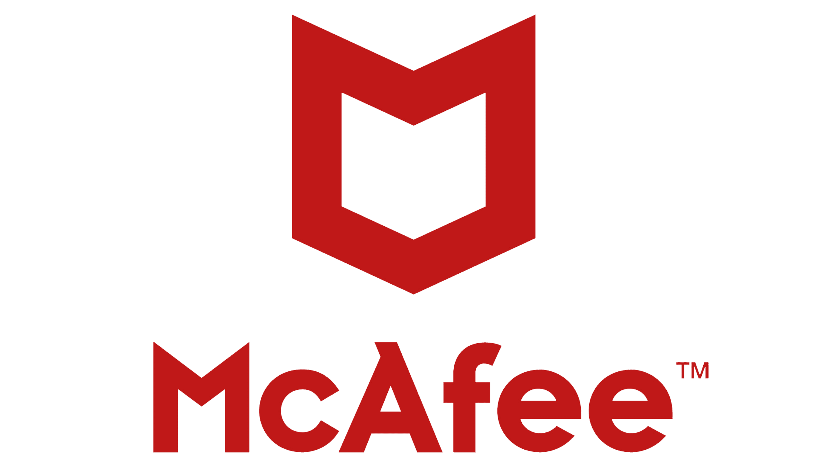
Dear Student

Your yerly subscription to McAfee Total Protection has been renewed and successfully updated. Your new amount will show up within the next day or two on your new invoice. You may log into your account at this link: (link placeholder) to see your new invoice. Product information is INVOICE No# SD15647884591X, Item Name – McAfee Total Protection, Start Date – 2024 December 01 End Date: 2025 December 01. Total - $340.42 USD Payment Method - Debit from account. If you wish to cancel your subscription and receive your REFUND then please call our Billing Department as soon as possible. You can Reach us on : +1–914 – 704 – 5723.

Regards, Billing Department Customer Care

